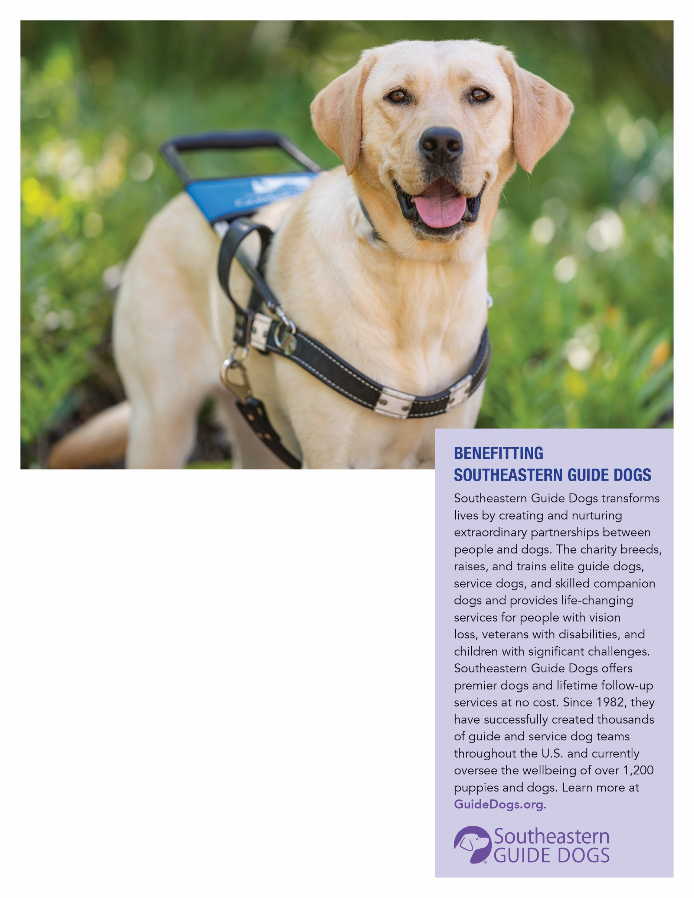

Additional Event Information

RSVP Information

**EVENT TITLE**

Event Address

**EVENT DATE**

**EVENT TIME**